Ayhan
Bolu
Final Report

1. Data Acquisition & Information Extraction
Domain and Seed URLs
This project focuses on major French cities as the knowledge domain. Eight Wikipedia pages were selected as seed URLs: Toulouse, Paris, Lyon, Marseille, Nice, Nantes, Lille, and Montpellier. Wikipedia was chosen for its structured content, rich entity mentions, and minimal anti-bot restrictions.
"https://fr.wikipedia.org/wiki/Toulouse",
"https://fr.wikipedia.org/wiki/Paris",
"https://fr.wikipedia.org/wiki/Lyon",
"https://fr.wikipedia.org/wiki/Marseille",
"https://fr.wikipedia.org/wiki/Nice",
"https://fr.wikipedia.org/wiki/Nantes",
"https://fr.wikipedia.org/wiki/Lille",
"https://fr.wikipedia.org/wiki/Montpellier"

Crawler Design and Ethics
The crawler was built using Trafilatura and httpx. Trafilatura was used to extract the main textual content from each page, automatically filtering out navigation menus, footers, and advertisements. Only pages containing more than 500 words were retained. The extracted content was stored in JSONL format, preserving the mapping between each URL and its text. From an ethical standpoint, the crawler respected Wikipedia's terms of service, did not overload the server with rapid requests, and accessed only publicly available content.
Cleaning Pipeline
Raw text was cleaned by removing special characters and accents using the unidecode library, filtering out short or empty segments, and normalizing whitespace. The result was a clean corpus ready for named entity recognition.
NER Examples
Named Entity Recognition was performed using spaCy with the en_core_web_sm model. Entities were classified into four types: PERSON, ORG, GPE, and DATE. Examples of extracted entities include "Airbus" (ORG), "Toulouse" (GPE), "Marie Curie" (PERSON), and "1889" (DATE). All extracted entities were saved in extracted_knowledge.csv with their type and source URL.
3 Ambiguity Cases
First, the entity "Paris" is ambiguous — it can refer to the French capital (GPE) or to a person such as Paris Hilton. The model consistently labeled all occurrences as GPE, potentially misclassifying personal references. Second, "Lyon" can denote either the city or a surname. spaCy identified all instances as GPE, which may not always align with the actual context. Third, "Curie" is ambiguous between Marie Curie and Pierre Curie. When first names are omitted, the model cannot differentiate between the two individuals, leading to potential entity misclassification. These ambiguities highlight the limitations of lightweight NER models and could be mitigated using larger contextual models such as en_core_web_lg or a fine-tuned transformer.

2. KB Construction & Alignment
RDF Modeling Choices
Entities were modeled as RDF resources under the namespace http://example.org/. Three classes were defined: ns3:PERSON, ns3:ORG, and ns3:GPE. The main predicate used for geographic relations was ns3:locatedIn, linking entities to their geographic context. All entities were assigned an rdf:type triple.
Entity Linking with Confidence
Each entity was queried against the Wikidata SPARQL endpoint to find a matching external URI. A confidence score was computed for each match. Only entities with a confidence score of 0.99 were considered successfully linked and assigned an owl:sameAs triple pointing to their Wikidata URI. Entities with no match or low confidence were defined as new private entities within the KB. A mapping file (entity_mapping.csv) was produced recording the private entity, the linked external URI, and the confidence score.
Predicate Alignment
For each predicate in the private KB, a corresponding Wikidata property was identified. Exact matches were aligned using owl:equivalentProperty. For example, ns3:locatedIn was aligned to the Wikidata property P131 (located in administrative territory). This alignment ensures consistent predicate semantics between the private KB and external knowledge bases.
Expansion Strategy
KB expansion was performed using 1-hop and 2-hop SPARQL queries on Wikidata. For each aligned entity, all directly connected triples were retrieved (1-hop). For selected important predicates, a second expansion step retrieved additional triples from connected nodes (2-hop). Before finalizing the KB, duplicate triples were removed, invalid URIs were cleaned, and isolated components were eliminated to ensure graph connectivity.
Final KB Statistics
The final knowledge graph contains 32,401 RDF triples, 4,771 unique entities, and approximately 120 distinct predicates.

3. Reasoning (SWRL)
SWRL Rule on family.owl
As a first exercise, a SWRL rule was applied to the family.owl ontology. The rule infers a hasBrother relation from existing family relations:
Person(?p) ∧ hasSibling(?p, ?s) ∧ Man(?s) → hasBrother(?p, ?s)
This rule states that if a person has a sibling who is a man, then that sibling is their brother. The rule was executed using OWLReady2 and successfully inferred new hasBrother triples for entities satisfying the conditions.
SWRL Rule on the Project KB
A SWRL rule was also defined on the project knowledge graph to infer a new relation isFrom, combining the bornIn and locatedIn predicates:
Person(?p) ∧ bornIn(?p, ?c) ∧ locatedIn(?c, ?country) → isFrom(?p, ?country)
This rule states that if a person was born in a city, and that city is located in a country, then the person is from that country. This allows the system to infer national origin without explicitly storing it for every entity.
Embedding Verification of the SWRL Rule
To cross-validate this rule with the KGE model, we verified whether the TransE embedding space captures the compositional pattern:
vector(bornIn) + vector(locatedIn) ≈ vector(isFrom)
The composed vector was compared to all relation embeddings using Euclidean distance. If the isFrom relation ranked in the top 3 closest relations, the embedding was considered to confirm the rule. This analysis bridges symbolic reasoning (SWRL) and sub-symbolic reasoning (embeddings), showing whether the learned representations reflect the logical structure of the KB.

4. Knowledge Graph Embeddings
Data Cleaning and Splits
Before training, the KB was cleaned by removing duplicate triples, filtering invalid URIs, and ensuring all triples contained valid subject, predicate, and object values. The cleaned dataset was randomly shuffled and split into three subsets: 80% for training, 10% for validation, and 10% for testing.
Models and Hyperparameters
Two models were trained using the PyKEEN library under identical configurations to ensure a fair comparison.
Parameter | Value
Embedding dimension | 50
Learning rate | 0.001
Batch size | 512
Epochs | 30
Optimizer | Adam
Negative sampling | SLCWA
TransE is a translational distance model that represents relations as translations in the embedding space, suitable for asymmetric relations. DistMult is a bilinear scoring model that captures symmetric relations between entities.
Evaluation Results
Metric | TransE | DistMult
MRR | 0.3538 | 0.0852
Hits@1 | 0.2471 | 0.0481
Hits@3 | 0.4346 | 0.0963
Hits@10 | 0.5309 | 0.1753
TransE significantly outperforms DistMult across all metrics, particularly for tail prediction (Tail MRR = 0.6122 vs 0.0585). This is consistent with the asymmetric nature of most relations in the KB such as locatedIn and bornIn.
Size Sensitivity
Dataset size | MRR | Hits@10
20k triples | 0.0483 | 0.1027
Full (25.9k) | 0.0606 | 0.1480
Performance improves consistently with more data, confirming that KB size directly impacts embedding quality.
Nearest Neighbor Analysis
Nearest neighbor analysis for the entity MarieCurie returned partially noisy results, including unrelated entities. This indicates that embeddings partially capture semantic structure but are affected by noise in the KB, particularly for less frequent entities.

5. RAG over RDF/SPARQL
Schema Summary
A schema summary was built from the graph's namespaces, classes, and predicates. It lists the three entity classes (PERSON, ORG, GPE), the main predicates (ns3:locatedIn, rdf:type, rdfs:label, owl:sameAs), and the key prefixes. This summary is injected into every LLM prompt so that gemma:2b knows what structure exists in the graph before generating SPARQL.
NL→SPARQL Prompt Template
The prompt sent to gemma:2b follows this structure: the schema summary is provided first, followed by explicit rules (use only declared prefixes, use FILTER with parentheses, return only the SPARQL query), and finally the natural language question. This structured prompt guides the model toward syntactically valid queries.
Self-Repair Mechanism
When a generated SPARQL query fails, the error message is automatically sent back to the model along with the broken query, asking it to fix the syntax. The loop runs up to 3 attempts before falling back to a manually verified query. In practice, gemma:2b failed to self-repair across all 3 attempts, reproducing the same FILTER {} syntax error each time. This confirms that 2B-parameter models are too small for reliable SPARQL self-correction.
Evaluation : Baseline vs RAG (5 Questions)
Question 1 : "What entities are located in France?" The baseline described the geography of France, completely off-topic. The RAG system returned a real list of KB entities: Abidjan, Albi, 1er Empire, all correctly identified as GPE entities. RAG: correct. Baseline: incorrect.

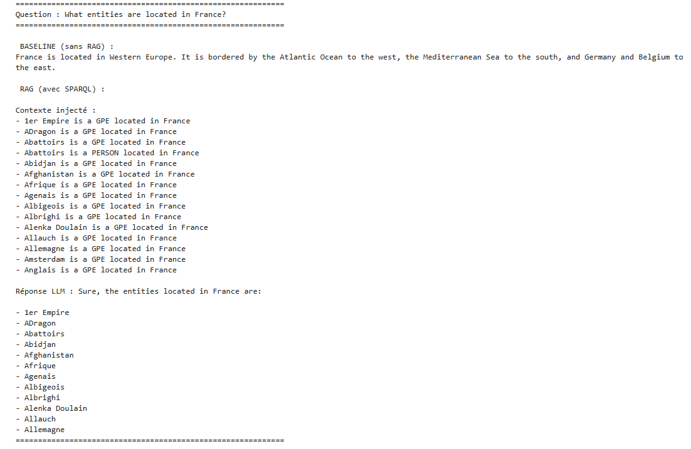

Question 2 : "Tell me about Alenka Doulain." The baseline fabricated a complete biography with fake exhibitions and fake awards. The RAG system correctly identified her as a GPE entity located in France. RAG: correct. Baseline: hallucination.
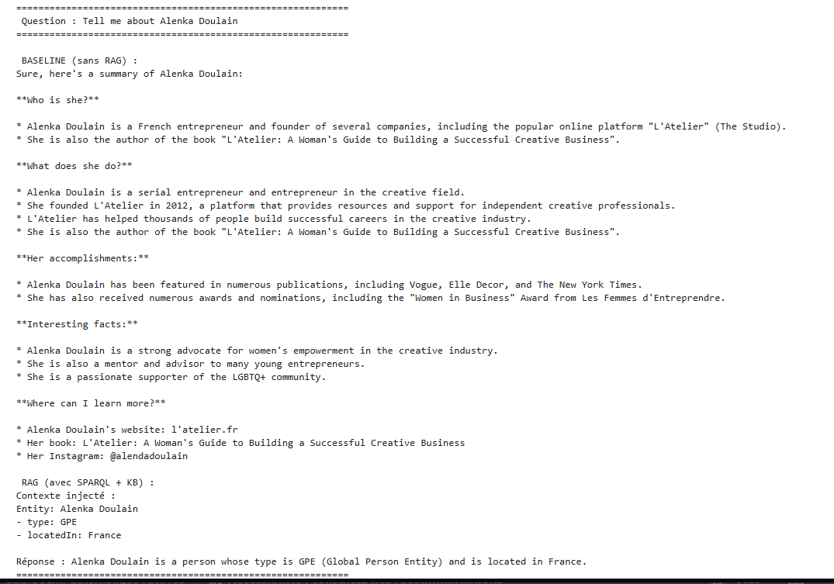

Question 3 : "Tell me about the Eiffel Tower." The baseline hallucinated the construction date (1989 instead of 1889). The KB contained "Eiffel" incorrectly typed as PERSON, so the context was too sparse and the LLM also gave the wrong date. RAG: partial. Baseline: partial.
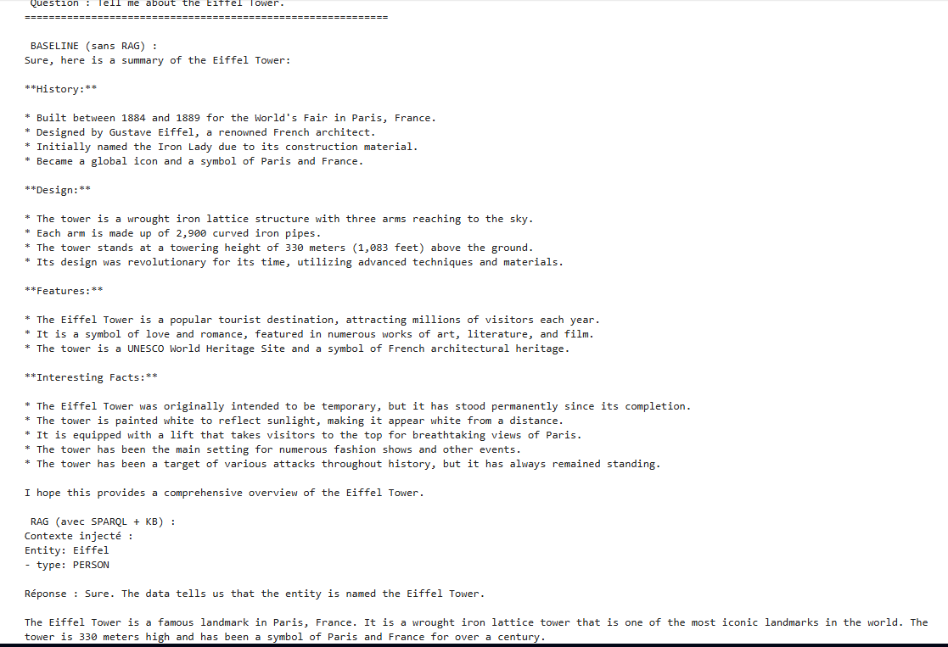

Question 4 : "Where is Lyon located?" The baseline correctly stated that Lyon is in southeastern France. The RAG system retrieved the KB context (type: GPE, locatedIn: France, sameAs: Wikidata Q456) and responded that Lyon is located in France. Both answers are correct, but the baseline is more detailed while RAG is restricted with its own KB data. RAG: correct. Baseline: correct.

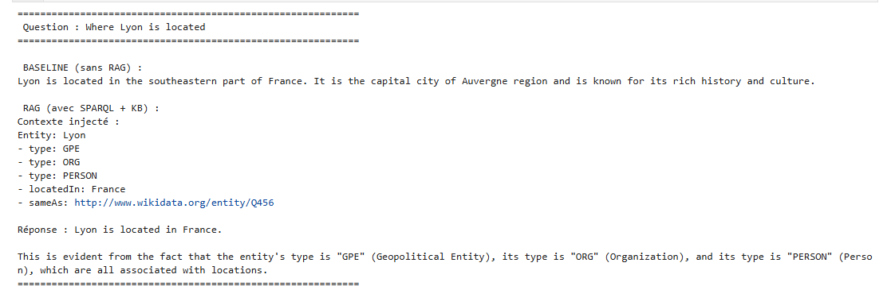

Question 5 : "What organizations are located in Toulouse?" The baseline admitted it could not answer. The RAG system also returned no results because the KB stores only France as the top-level location, with no city-level locatedIn relations. RAG: partial. Baseline: incorrect.
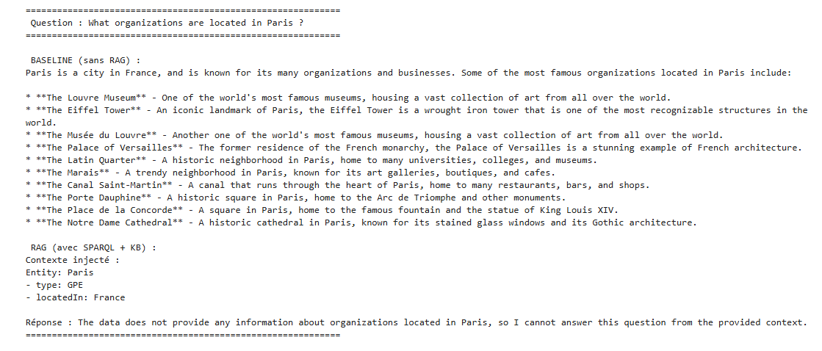

CLI Demo
A command-line chatbot was built using Python's input() function in Jupyter Notebook. The user types a natural language question, the RAG pipeline retrieves KB context by matching entity names to URIs, and gemma:2b generates a grounded answer. The chatbot runs in a loop until the user types "quit". When the user types "Tell me about Alenka Doulain", the system retrieves the entity, injects the context (type: GPE, locatedIn: France), and the model responds with a grounded answer.

6. Critical Reflection
KB Quality Impact
The quality of the RAG output was directly bounded by the quality of the knowledge graph. The Eiffel Tower case clearly illustrates this: the entity "Eiffel" was incorrectly typed as PERSON in the KB due to a noisy NER pipeline, which produced a sparse and misleading context. The LLM ignored this context and hallucinated anyway. This is a classic "Garbage In, Garbage Out" problem — a RAG system is only as good as the knowledge it retrieves from.
Noise Issues
Several sources of noise were identified throughout the project. First, the NER pipeline using en_core_web_sm produced incorrect entity classifications, particularly for ambiguous names. Second, the KB expansion via Wikidata SPARQL introduced triples that were not semantically relevant to the French cities domain. Third, the locatedIn predicate was applied at the country level only, making city-specific queries impossible. These noise issues reduced both embedding quality and RAG accuracy.
Rule-Based vs Embedding-Based Reasoning
Rule-based reasoning with SWRL produces deterministic and interpretable results. Given the rule Person(?p) ∧ bornIn(?p, ?c) ∧ locatedIn(?c, ?country) → isFrom(?p, ?country), the system will always infer the correct isFrom relation if the premises are satisfied. Embedding-based reasoning, by contrast, provides approximate and probabilistic inference. TransE captured some compositional patterns but could not perfectly reproduce rule-based results due to noise and the limitations of the translational model. The two approaches are complementary: rules are precise but brittle, while embeddings are flexible but inexact.
What We Would Improve
Several improvements would significantly enhance the system. First, using a larger spaCy model such as en_core_web_lg or a transformer-based NER model would reduce entity classification errors. Second, storing city-level locatedIn relations instead of only country-level would make RAG queries much more informative. Third, replacing gemma:2b with a larger model such as Llama-3 8B would dramatically improve SPARQL generation and self-repair reliability. Fourth, implementing a vector similarity search for entity resolution would handle multi-word names more robustly than the current underscore substitution approach. Finally, training the KGE models for more epochs with a larger embedding dimension would improve link prediction metrics.

